1. Modified class diagram with strategy pattern

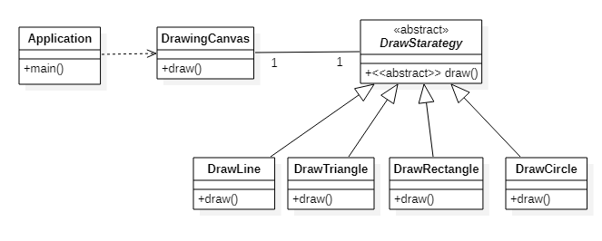

Sequence diagram to draw a line and two circles

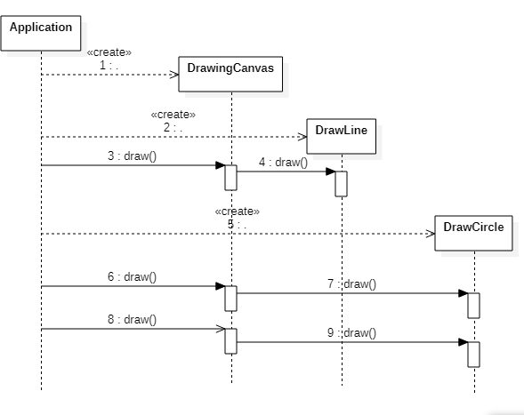

1. Modified class diagram of the bank application with the strategy pattern

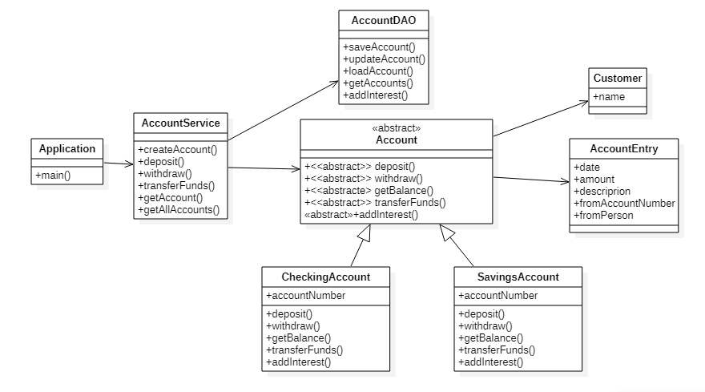

1. Sequence diagram showing addInterest() method.

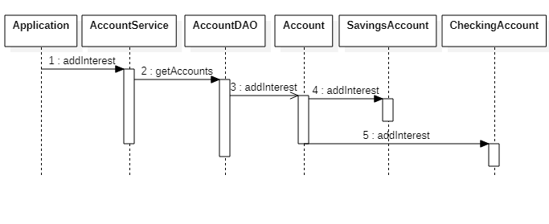

1. Modified code of the bank application is attached.
2. Modified class diagram and sequence diagram using template method.

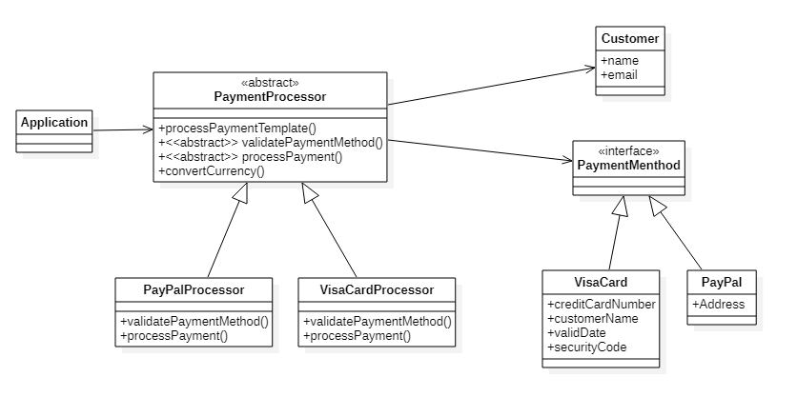

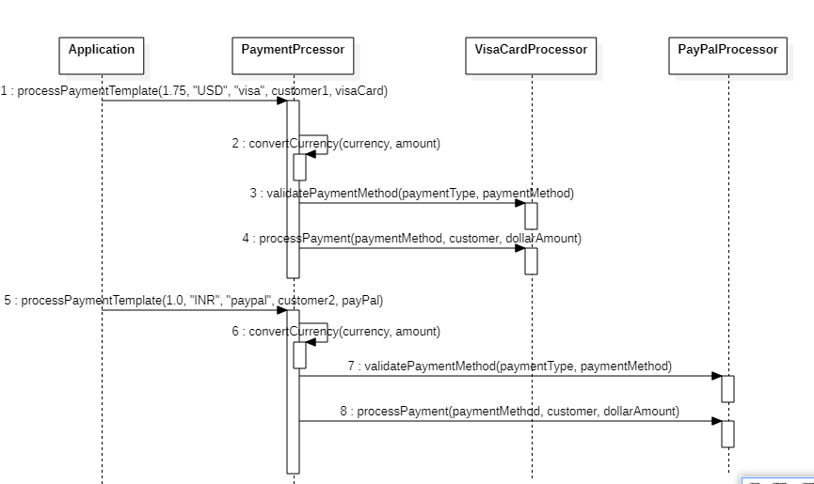

1. Modified code with template design attached.